**BioGraphy:**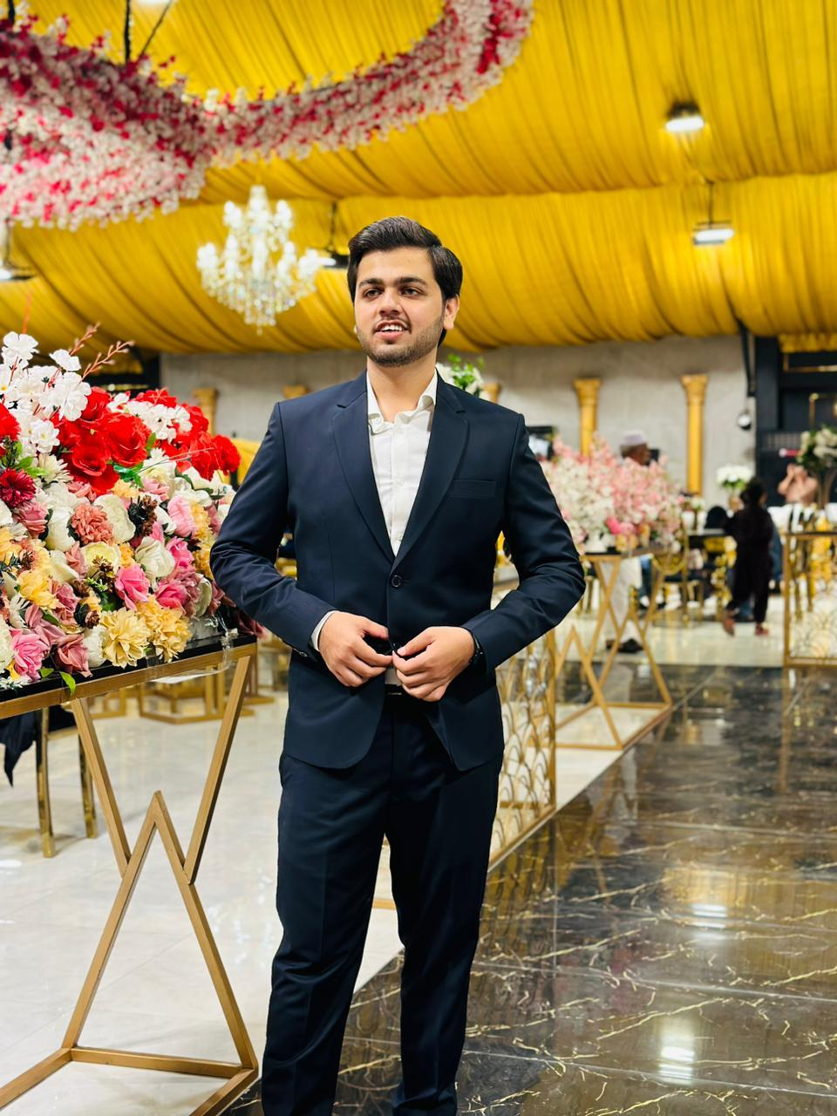

Myself Muneeb,I am curious palate,and passionate

about exploring diverse food cultures. I have an

insatiable appetite for trying new and unique

dishes from around the world. I love immersing

myself in the flavours, spices, and cooking

techniques that each culture has to offer. My

adventurous spirit drives me to seek out

hidden gems and local eateries wherever I go.

My interest in food goes beyond just tasting;

I enjoy learning about the history and traditions

behind each culinary masterpiece. With every bite,

I broaden my culinary horizons and shares my food

adventures with others, inspiring them to embark

on their own gastronomic journeys.